**Force Transducer Calibration**

Last updated on 08 December 2020 by Faruk Moonschi

**Overview**

This document explains how to use a worksheet in Excel to deduce parameter values that SLControl needs to control experiments and calibrate force measurements in the output files.

**Additional resources**

* Force_transducer_calibration_template.xlsx – should be in the same folder on Teams (or wiki.campbellmusclelab.org) as this document
* SLControl manuscript - <https://www.physiology.org/doi/full/10.1152/ajpheart.00295.2003>
* Getting started tutorial - <http://www.uky.edu/~kscamp3/SLControl/Tutorials/tutorials_header.html>
* Video – should be in the same folder on Teams as this document

**Need more help?**

* Check the resources, then see Ken

**Procedure to find “_FORCE_CALIBRATION_”**

1. Take a small metal piece (you can cut the tail of a resistance) like 0.5 cm. Keep it aside.
2. Place the force transduce trough on top of the metal piece between two chambers of the stage. As shown in the figure below:

1. Add a little wax on the trough and melt the wax (using a soldering station, see next image to know how our soldering station looks like) around the force transducer rod and place that metal piece on the melted wax to make a T shape (previous image). Allow the wax to cool down and test by pulling lightly the T-shape to see if the T-shape is stable. If the T-shape is not that stable, add extra wax and melt it on the T-shape join. Repeat until stable.

1. Lift the force transducer trough up and away from the stage so that when you try to remove the force transducer from the stage, you will not accidentally break it. Take the force transducer out from the stage by very carefully removing the screws using a 3/32 Hex Screwdriver. Make sure you don’t hit the force transducer trough on something which might break the force transducer.
2. Mount the force transducer on a vice so that the force transducer rod is hanging down. Use a level to make sure the force transducer was placed perfectly horizontal and the trough is perfectly vertical. See the next image for the position of the transducer on the vice.

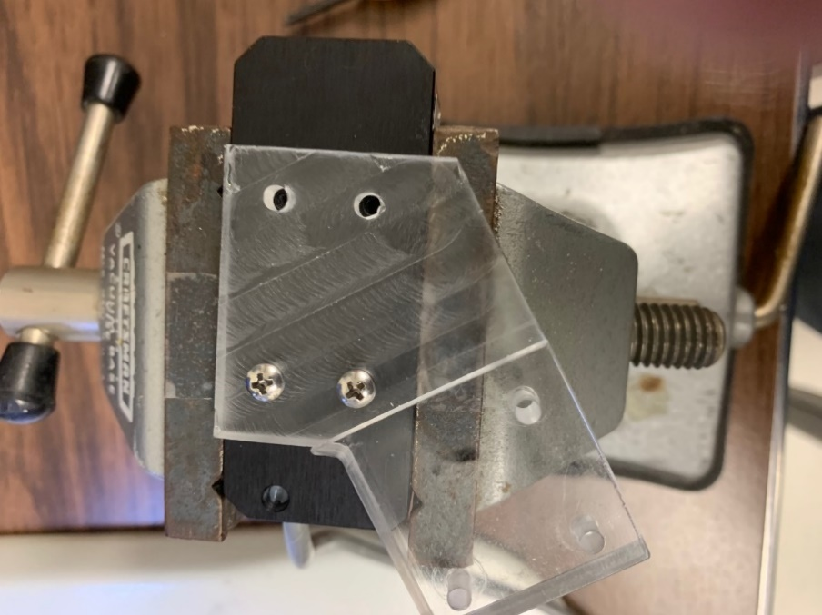

1. Take some (about 10) 9 mg to 500 mg weights (Ken has a brown bottle with weights in epi tubes, see picture below) to get voltage differences for different weights.

* 1. Use a weight from one of the white epi tubes for calibration. We will use weights in the blue tubes for calibration validation.
  2. Hang a weight on the T-shape (made earlier) and place the weight as close to the transducer rod as possible. See the following image.

* 1. When the voltage gets stable on the oscilloscope, press the “CURSOR” button on the oscilloscope. When the force record crosses the first vertical line, quickly remove the weight from the force transducer. This will give a step-change in the voltage on the oscilloscope (as shown in the following image)

* 1. Freeze the screen by pressing the “RUN/STOP” button.
  2. You can move the vertical lines using the switches beside the screen (2nd and 3rd buttons from the bottom for the left and right verticle line respectively) and the dial besides the blue LED light (not shown in the picture).
  3. Record the voltage difference displayed right side of the screen on the Force_trasducer_calibration_template.xlsx found in the same folder as this protocol in the Teams.
  4. Using a balance get the mass of the weight in grams. Record the weight on the excel sheet. (As our balance is in another room, you can write down the weight containing the tube’s number on the excel sheet and measure the weights at the end)
  5. Restart the oscilloscope by pressing the “RUN/STOP” button again.
  6. Repeat the voltage change and weight measurement with all remaining rods in the white tubes.

1. Your calibration value (of “**_FORCE_CALIBRATION_”)** is the slope of the fitted line on that excel sheet.

**Adding “_FORCE_CALIBRATION_” to SLControl**

1. Open C:\Program Files (x86)\SLControl\Executable\apparatus_calibration_parameters.txt
2. Replace the number after “_FORCE_CALIBRATION_” with the slope of the Force vs voltage plot. Currently, this value is 5.276e-4
3. Update the calibration date (_CALIBRATION_DATE_)
4. Save the file and go for validation of the calibration

**Calibration Validation:**

1. Open the SLControl software as an administrator
2. Start SL_SERC experiments
3. Change “Area” to 1 (for simplicity of calculation). “Data Points” to 10000 and add the “Path” where you want to save the slc files
4. Follow the following steps to find the force from SLC control (use the green epi tubes’ weights from that brown bottle)
   1. Use one weight, measure its weight using the analytical balance
   2. Hang the weight on the T-shaped made on the force transducer turf
   3. When the weight stops swing, if any, start collecting data on the SLControl and then remove the weight from the T-shape.
   4. When SLControl is done collecting the data, it will give a step change in force value.
   5. Open the slc file with SLControl
   6. Transform the voltage to N (on the SLC control, Transform>>Transform to Calibration value)
   7. Use D key on the keyboard to move the cursors and get a y difference between the step force change generated by the quick removal of the weight.
   8. Record this y difference on the excel sheet
   9. Monitor the % error
5. Repeat #4 with 3-4 more weight. If the % error is acceptable. You are done with calibrating. Talk to Ken if the error seems reasonable.
6. Carefully remove the T-shape rod and the wax from the trough using heat from the soldering station.
7. Then, carefully remove the force transducer from the vice and put it back where it was on the stage.
8. If you have removed any cable tie (aka zip tie), please put a new cable tie to keep all the wires around the stage together.